ENTERPRISE TECHNICAL SPECIFICATION & ARCHITECTURE GUIDE
DocMind (Ultimate Chatbot)
AI-Powered Multi-Modal Retrieval-Augmented Generation (RAG) & Intelligence Platform

📌 SYSTEM ARCHITECTURE SUMMARY
• Architecture: Zero-Downtime Blue/Green Vector Store (Qdrant Port 6333) with Cross-Process File Lock
• Document Parsing: IBM Docling (DocLayNet + TableFormer) + RapidOCR 2x Full-Page Bitmap Scanning
• Retrieval Engine: Two-Stage Hybrid Retrieval (BAAI BGE-M3) + Neural Cross-Encoder Reranker (bge-reranker-v2-m3)
• Speech-to-Text: Real-Time Multi-Provider Streaming (AssemblyAI, Deepgram, Faster-Whisper, Vosk, Windows SAPI)
• Orchestration: Dual Provider (Local Ollama Llama 3.1 & Cloud Google Gemini Flash) with Sub-10ms Smalltalk Fast-Path
• Telemetry & Persistence: MongoDB Audit Logs, Visitor Geo-IP Intelligence, Feedback Queues, and Lead Capture

1. Executive Summary
DocMind (also known as Ultimate Chatbot) is an enterprise-grade conversational AI and multi-modal document intelligence platform. Engineered to ingest complex heterogeneous data—including brochures, financial reports, spreadsheets, multi-slide presentations, and dynamically rendered web portals—DocMind empowers end users to interrogate extensive repositories with high factual precision through interactive chat and low-latency voice streaming.
By coupling advanced structural layout decomposition (Docling) with two-stage neural reranking and zero-downtime Blue/Green collection swapping, the platform eliminates common enterprise RAG failure modes such as table hallucination, semantic drift, and service locking during document updates.

2. High-Level System Architecture
The system decouples high-concurrency client chat sessions from administrative background ingestion tasks across two dedicated application instances:
+---------------------------------------------------------------------------------------+
| DOCMIND SYSTEM TOPOLOGY |
+---------------------------------------------------------------------------------------+
| User Browser (Port 5000: Web/Mic) | Administrator UI (Port 5001: Ops/Logs) |
| • Fast-Path Intent Router (<10ms) | • FIFO Background Queue Worker Thread |
| • Real-Time WebSocket Audio Stream | • Live Ingestion & Deletion Pipeline |
| • MongoDB Session & Lead Management | • Visitor Intelligence & Telemetry |
+------------------------------------------+-------------------------------------------+
|
+-------------------------------+-------------------------------+
v v
+-------------------------------------------+ +-----------------------------------------+
| INGESTION PIPELINE | | RETRIEVAL & INFERENCE ENGINE |
| • IBM Docling (DocLayNet + TableFormer) | | • Qdrant Dense Vector Search (Top-50) |
| • RapidOCR 2x Full-Page Bitmap Scan | | • BGE Cross-Encoder Reranker (Top-10) |
| • Semantic Chunk Header Enrichment | | • 3-Turn Dialogue Memory Synthesis |
| • Blue/Green Atomic Slot Swapping | | • Ollama (Llama 3.1) / Gemini Flash LLM |
+-------------------------------------------+ +-----------------------------------------+
|
v
+---------------------------------------------------------------------------------------+
| DATA & STORAGE LAYER: Qdrant Server (:6333) | MongoDB (:27017) | portalocker write.lock |
+---------------------------------------------------------------------------------------+

3. Architecture Diagrams & Data Flow

3.1 Document Ingestion & Vectorization Pipeline Diagram
The Ingestion Pipeline transforms unstructured multi-format files and cloud URLs into semantically enriched vectors while maintaining zero query disruption:
+---------------------------------------------------------------------------------------+
| DOCUMENT INGESTION & VECTORIZATION PIPELINE |
+---------------------------------------------------------------------------------------+
[ Multi-Source Intake: PDF, DOCX, XLSX, PPTX, CSV, TXT, RTF, Scraped URLs, G-Drive ]
|
v
[ 1. DEEP LAYOUT PARSING & OCR ]
• IBM Docling Engine (DocLayNet Layout Segmentation + TableFormer Neural Tables)
• RapidOCR 2x Full-Page Bitmap Scan (ensures image-only / scanned PDFs are parsed)
• Native parsers for Office spreadsheets (openpyxl), Word (python-docx), and CSV
|
v
[ 2. CHUNKING & CONTEXTUAL HEADER ENRICHMENT ]
• RecursiveCharacterTextSplitter (chunk_size=2000, chunk_overlap=200)
• Prepend metadata header: "Document: <Name> | Section: <Path> | Page: <N>"
|
v
[ 3. DENSE EMBEDDING GENERATION ]
• BAAI/bge-m3 Model (1024-dimensional semantic embeddings via Ollama / HuggingFace)
|
v
[ 4. ZERO-DOWNTIME BLUE/GREEN ATOMIC SLOT SWAP ]
• Acquire inter-process file lock (portalocker on write.lock)
• Clone active collection -> standby collection (docmind_blue <-> docmind_green)
• Write new vectors to standby collection
• Atomic pointer swap in active_slot.json in ~1ms (via temporary file + os.replace)
• Qdrant HTTP Server (:6333) executes zero-downtime collection management
+---------------------------------------------------------------------------------------+
📌 INGESTION PIPELINE WALKTHROUGH
• 1. Ingestion Inflow: Accepts drag-and-drop batch files or Playwright headless browser web scrapes.
• 2. Docling Layout OCR: Reconstructs reading order, handles multi-column spans, and generates structured markdown tables.
• 3. Header Enrichment: Injects document title and section breadcrumbs into each chunk to eliminate semantic drift.
• 4. Blue/Green Swapping: Writes only to the standby Qdrant slot; swaps pointer in ~1ms so live user chats never lock.

3.2 Retrieval-Augmented Generation (RAG) & Inference Flow Diagram
+---------------------------------------------------------------------------------------+
| RAG & MULTI-STAGE INFERENCE WORKFLOW |
+---------------------------------------------------------------------------------------+
[ User Input: Web Chat Text Query OR Microphone Voice Stream (Transcribed by STT) ]
|
v
[ 1. INTENT CLASSIFICATION & FAST-PATH ROUTER (utils/smalltalk.py) ]
• If greeting / thanks / pleasantry ---> Instant template response (<10ms latency)
• If domain knowledge question ---> Proceed to Two-Stage Retrieval Pipeline
|
v
[ 2. STAGE 1: DENSE VECTOR RETRIEVAL (BAAI/bge-m3 + Qdrant Active Slot) ]
• Encode query into dense vector; retrieve Top-50 candidate chunks (TOP_K=50)
|
v
[ 3. STAGE 2: NEURAL CROSS-ENCODER RERANKING (BAAI/bge-reranker-v2-m3) ]
• Compute query-passage token cross-attention scores with FP16 precision
• Rank and filter down to Top-10 highest-quality passages (RERANKER_TOP_N=10)
|
v
[ 4. CONTEXT AUGMENTATION & PROMPT SYNTHESIS ]
• Pull last 3 dialogue turns (CONVERSATION_HISTORY_LIMIT=3) from session store
• Assemble grounded prompt with strict factual truthfulness & markdown table rules
|
v
[ 5. DUAL LLM INFERENCE & TELEMETRY LOGGING ]
• Primary: Local Ollama (LLaMA 3.1 8B) or Cloud Google Gemini (Gemini 2.0 / 3.6 Flash)
• Fallback: Dynamic switch to Mistral 7B if user registers dissatisfaction
• Output Markdown, spec comparison tables, TTS trigger, and log to MongoDB
+---------------------------------------------------------------------------------------+
📌 RAG INFERENCE WALKTHROUGH
• 1. Fast-Path Filter: Identifies smalltalk in sub-10ms, skipping vector and model overhead.
• 2. Candidate Search: Retrieves Top-50 passages via Qdrant cosine similarity.
• 3. Cross-Encoder Reranker: Filters false positives down to Top-10 relevant chunks via BGE-Reranker-v2-m3.
• 4. Prompt Synthesis: Enforces ground truth, formats multi-document tables, and streams answer with TTS.

4. Technology Stack & Comprehensive Library Manifest
Category | Libraries & Packages | Version | Role & Implementation
Web & Real-Time | Flask, Flask-SocketIO, Werkzeug, websockets | 3.1.3 / 15.0.1 | Powers main user chat (app.py) and admin portal (admin_app.py) with bidirectional audio streaming.
RAG Orchestration | langchain, langchain-core, langchain-ollama, langchain-google-genai | 1.3.14 / 1.1.0 | Prompt template compilation, LCEL chaining, and multi-provider LLM abstraction.
Vector Database | qdrant-client, faiss-cpu | 1.18.0 / 1.14.3 | Qdrant HTTP server client supporting zero-downtime Blue/Green slot swapping on port 6333.
Embeddings & Reranker | FlagEmbedding, transformers, tiktoken, numpy | >=1.2.11 / 2.5.1 | BAAI/bge-m3 dense embeddings and BAAI/bge-reranker-v2-m3 neural cross-encoder execution with FP16.
Document Extractors | docling, pdfplumber, python-docx, python-pptx, openpyxl, xlrd, striprtf, playwright | Latest / 3.1.5 | Deep document layout OCR, neural table extraction, Office formats parsing, and headless browser scraping.
Speech-to-Text (STT) | deepgram-sdk, assemblyai, faster-whisper, vosk, pywin32 | Latest / 312 | Decoupled audio pipeline supporting cloud WebSockets and local offline CTranslate2 Whisper models.
Persistence & Locking | pymongo, portalocker, python-dotenv | 4.7.3 / 3.2.0 | MongoDB telemetry storage (chat logs, visitors, leads) and inter-process file locking for safe concurrency.

5. Core Subsystems & Architectural Deep-Dives

5.1 Multi-Format Document Ingestion Engine (Docling & Fallbacks)
DocMind routes complex PDF and Office files to IBM Docling. Using DocLayNet for visual layout segmentation and TableFormer for structural table recognition, the system accurately extracts multi-column text and converts embedded data matrices into clean markdown tables. Scanned PDFs are automatically treated via RapidOCR full-page bitmap scanning at 2x resolution.

5.2 Blue/Green Vector Database Strategy & Atomic Swapping
To ensure non-blocking read queries during heavy document re-indexing or deletion, the system maintains two Qdrant collections (docmind_blue and docmind_green). Ingestion writes exclusively to the standby slot under an inter-process file lock (portalocker). Once indexing completes, an atomic pointer switch (~1ms) updates active_slot.json, instantly routing user traffic with zero downtime.

5.3 Two-Stage Retrieval & Cross-Encoder Reranking Pipeline
Standard bi-encoder embeddings retrieve Top-50 candidate passages from Qdrant. To eliminate false positives, BAAI/bge-reranker-v2-m3 (cross-encoder with FP16 precision) performs exhaustive token-level cross-attention between query and candidates, re-scoring and filtering down to the Top-10 highest-precision chunks for the LLM prompt.

5.4 Multi-Provider Real-Time Speech-to-Text (STT) Subsystem
The voice pipeline ingests raw 16kHz PCM audio over WebSockets. Admins can hot-swap STT engines in real-time between AssemblyAI Streaming v3, Deepgram Nova-3, local Faster-Whisper, offline Vosk, or native Windows SAPI without server restart.

5.5 Smalltalk Fast-Path Intent Routing & Dual LLM Provider Support
Conversational pleasantries and system questions are resolved by utils/smalltalk.py in under 10ms. Domain queries leverage local Ollama (Llama 3.1) or Google Gemini Flash, with automatic failover to a Secondary LLM (Mistral 7B) if user dissatisfaction is detected.

5.6 Telemetry, Lead Generation, & MongoDB Persistence
DocMind maintains comprehensive audit logs in MongoDB, including visitor IP and Geo-location tracking, turn-by-turn chat histories, user lead capture (Name, Email, Phone), and negative feedback queues for rapid issue triage.

6. Project Screenshots & Feature Walkthrough
Below is the complete visual walkthrough of DocMind, demonstrating user conversational interactions, comparative matrices, lead capture, and the back-office administrative panel:

Figure 6.1: Main Conversational Interface (DocMind)
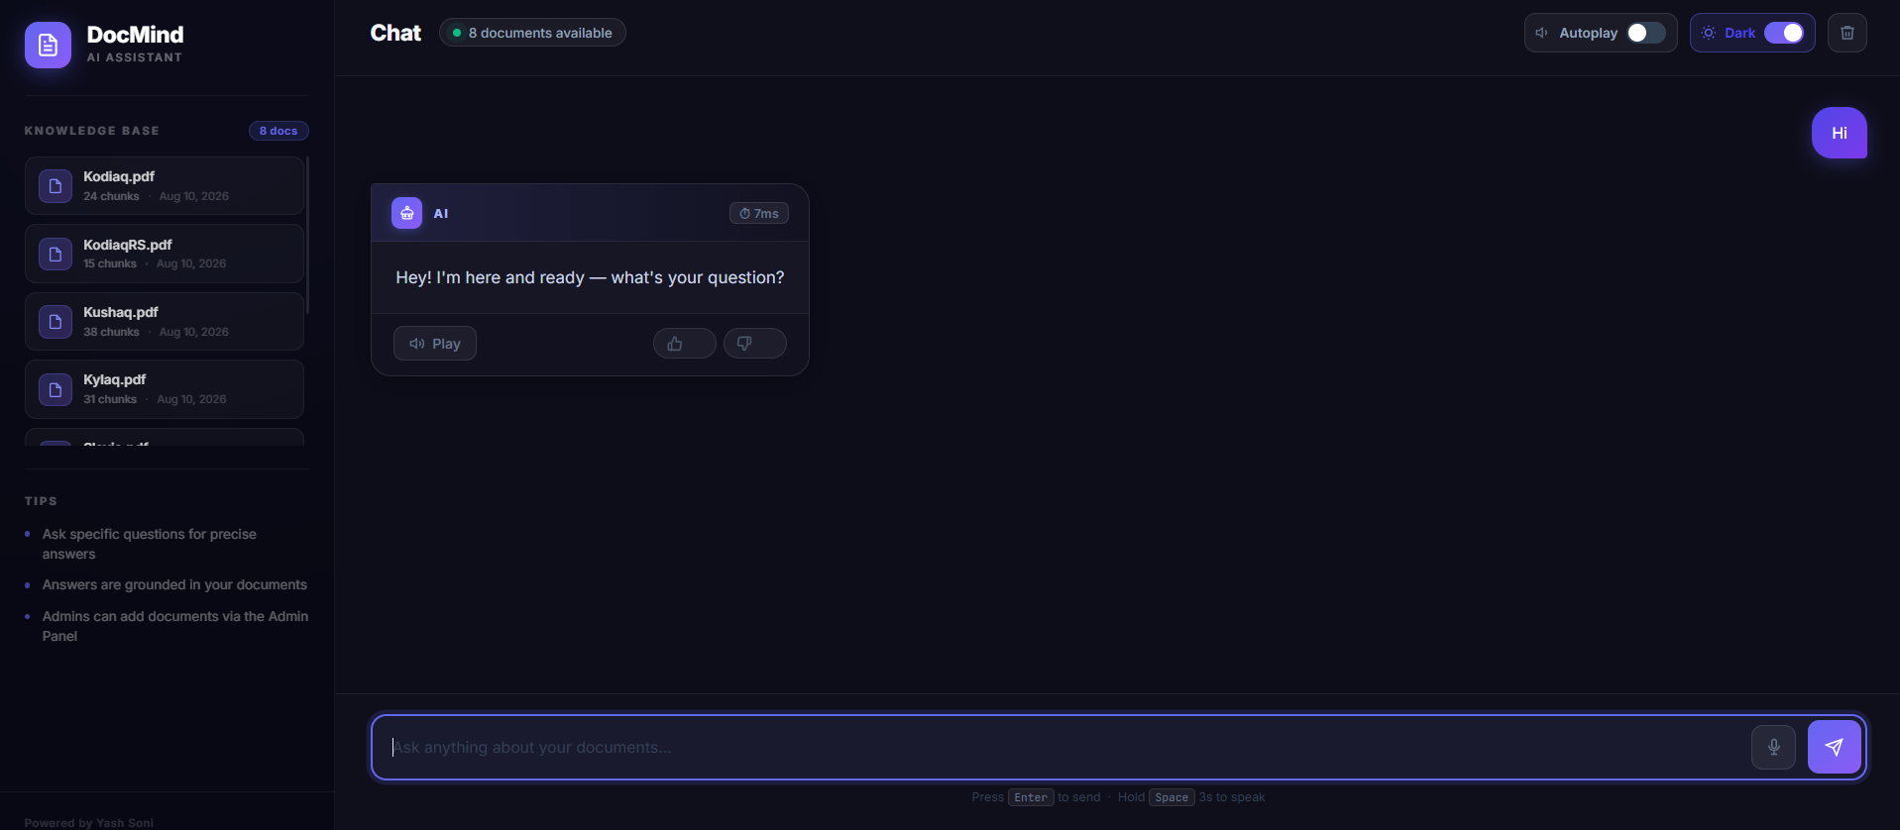
Description: The dark-themed chat interface showing the active knowledge base sidebar (8 documents available: Kodiaq.pdf, Kushaq.pdf, Kylaq.pdf, etc.), voice input trigger, autoplay toggle, and greeting state.

Figure 6.2: Grounded RAG Query Response & Audio Synthesis
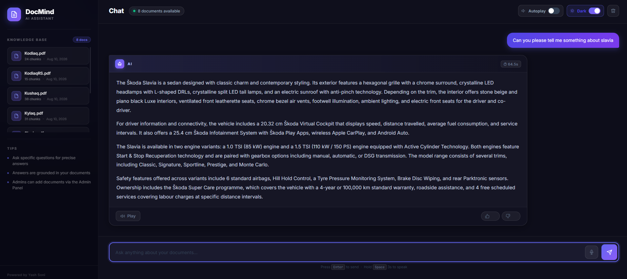
Description: Contextual answer generated from ingested Skoda Slavia technical specifications. Displays execution latency (64.5s), TTS audio playback button, and granular like/dislike rating controls.

Figure 6.3: Lead Generation & Contact Capture Modal
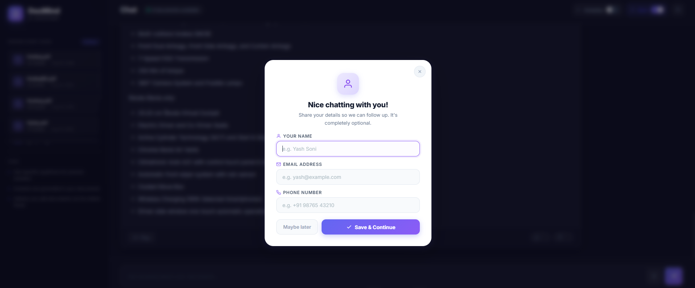
Description: User contact capture modal prompted during conversation. Collects Name, Email Address, and Phone Number, automatically persisting records to MongoDB for CRM follow-up.

Figure 6.4: Cross-Document Comparative Specification Table
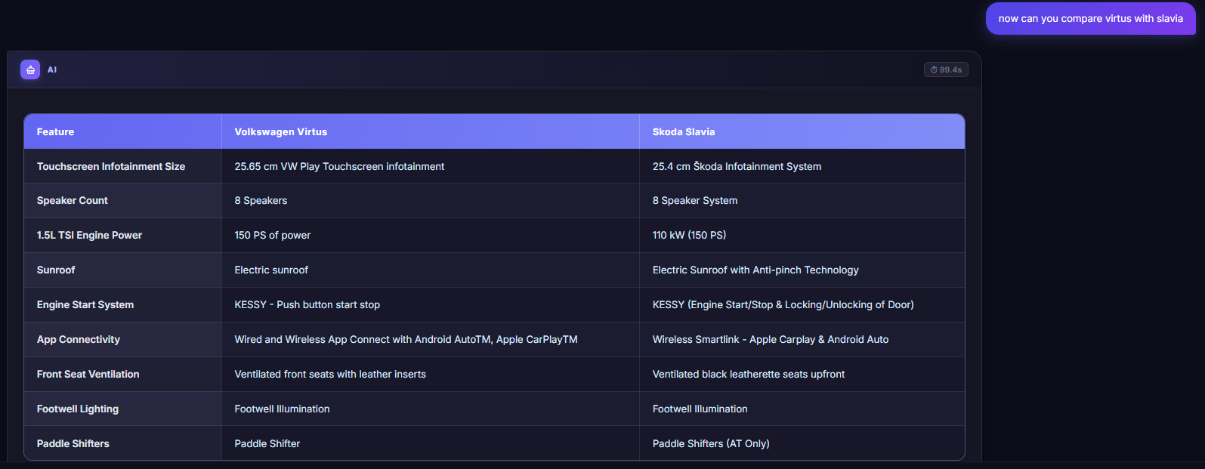
Description: Multi-document synthesis comparing the Volkswagen Virtus and Skoda Slavia across infotainment size, speakers, engine power, and safety features in a formatted markdown table.

Figure 6.5: Comparative Details & Exclusive Attribute Breakdown
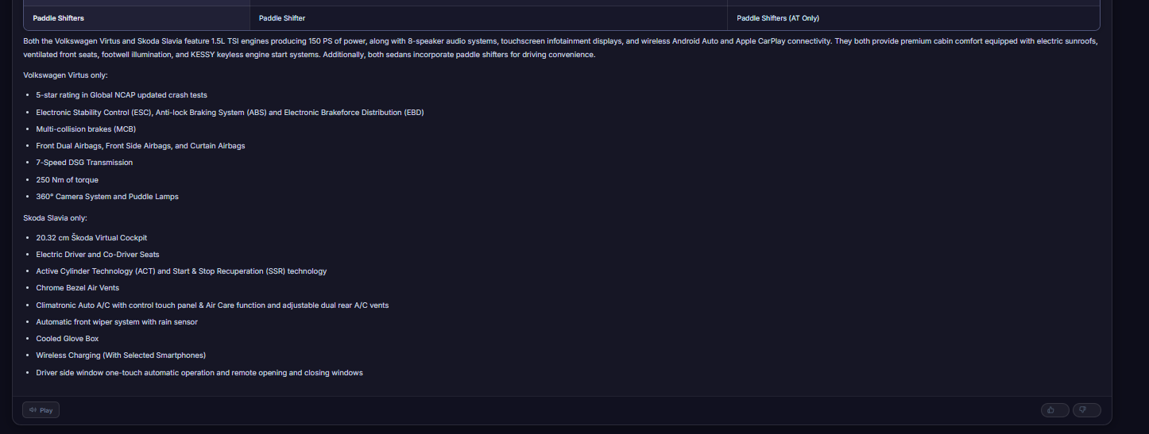
Description: Continuation of vehicle comparison separating shared platform attributes from exclusive differentiators (e.g. 5-star NCAP rating vs Virtual Cockpit).

Figure 6.6: Ultra-Fast Smalltalk Response (8ms Latency)
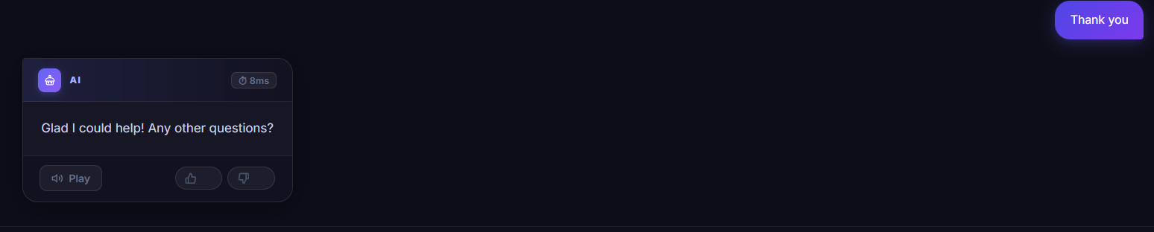
Description: Sub-10ms response time for conversational pleasantries ('Thank you') executed via the fast-path regex router without model or vector database overhead.

Figure 6.7: Admin Panel — Knowledge Base Manager
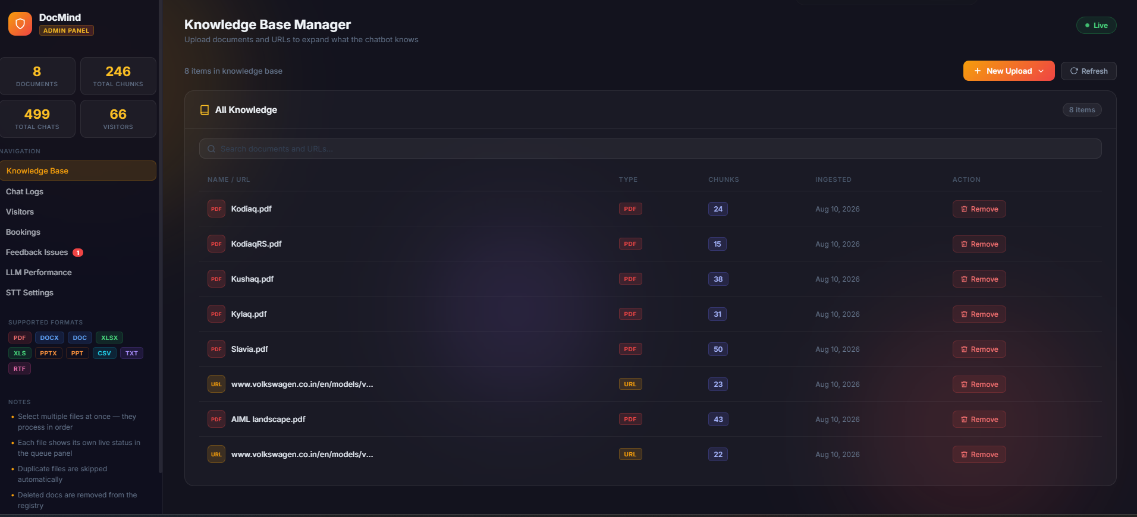
Description: Knowledge base management console displaying active documents (8 docs, 246 total chunks, 499 total chats, 66 visitors), chunk allocations, and one-click removal controls.

Figure 6.8: Ingestion Source Selector
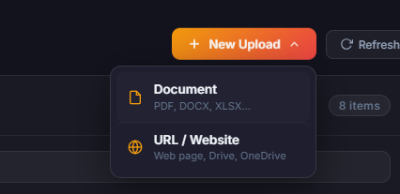
Description: Dropdown menu in the admin panel providing options for multi-format local document uploading or live web and cloud URL scraping.

Figure 6.9: Multi-Format Batch Ingestion Dropzone
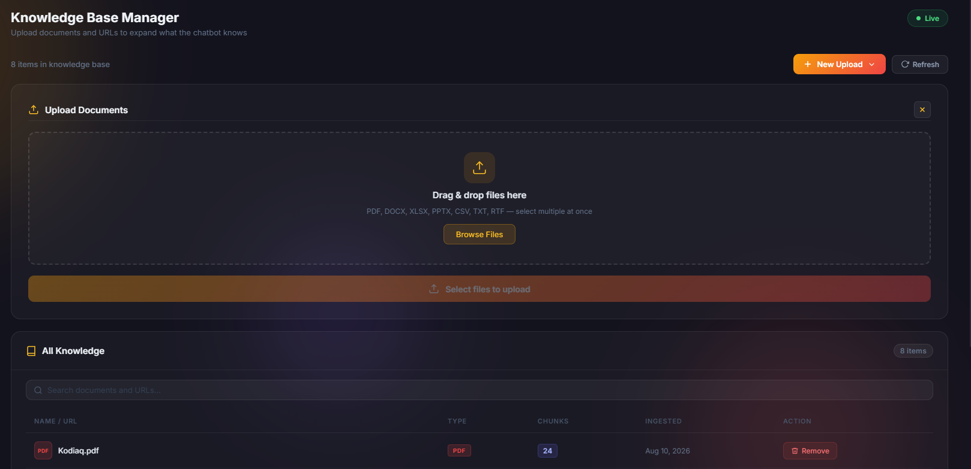
Description: Drag-and-drop batch upload area supporting PDF, DOCX, XLSX, PPTX, CSV, TXT, and RTF files with real-time serial queue processing.

Figure 6.10: Web Page & Cloud Storage Scraper Modal
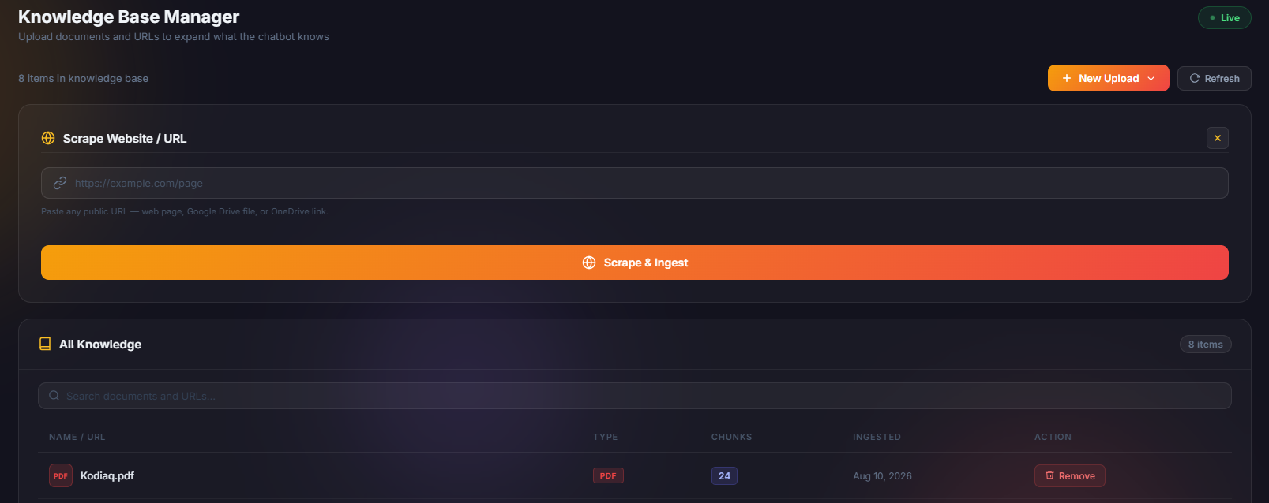
Description: URL ingestion modal allowing extraction and vectorization of public web pages (via Playwright), Google Drive files, and OneDrive shares.

Figure 6.11: Real-Time Interaction & Chat Auditing Logs
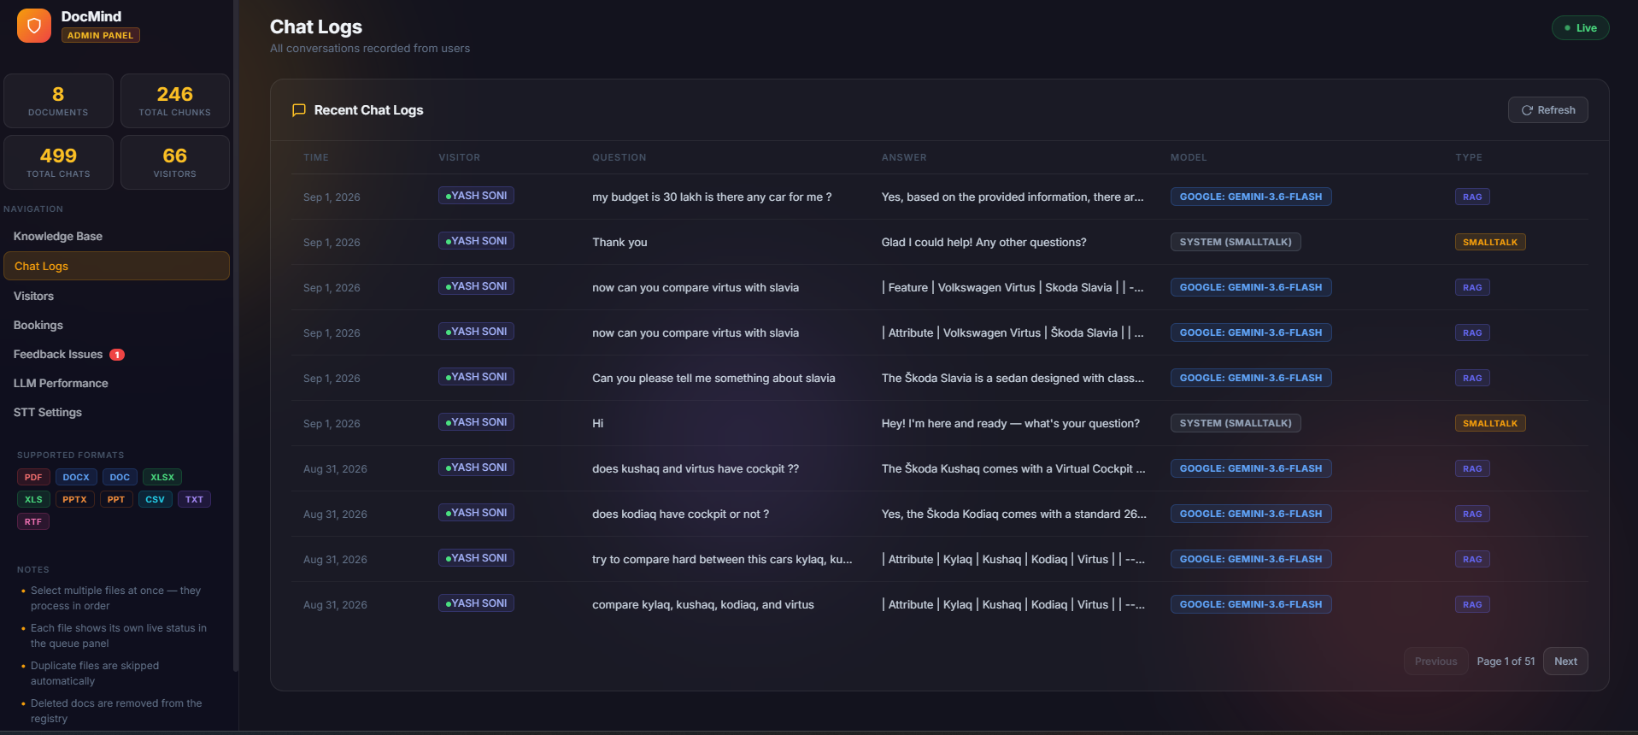
Description: Centralized audit log recording visitor IDs, questions, AI answers, model attribution (Gemini Flash, Smalltalk), and query classification (RAG vs Smalltalk).

Figure 6.12: Visitor Intelligence & Geo-Location Tracking
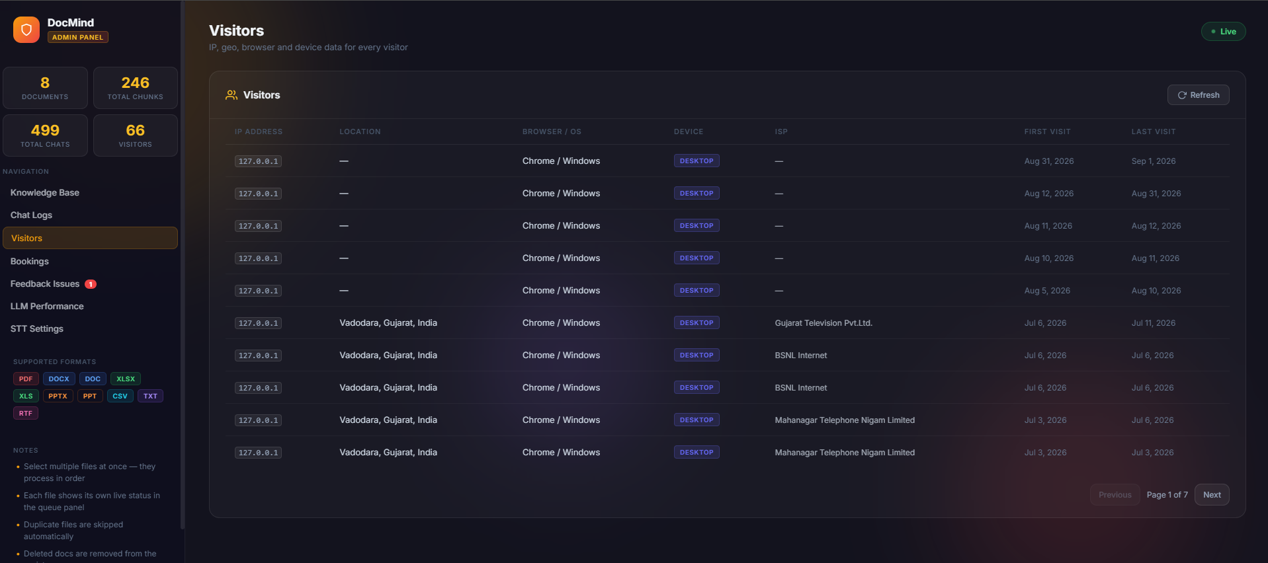
Description: Telemetry screen displaying visitor IP addresses, resolved geographic locations (e.g. Vadodara, Gujarat, India), browser/OS, device type, ISP, and visit timestamps.

Figure 6.13: Feedback Issue Triage Center
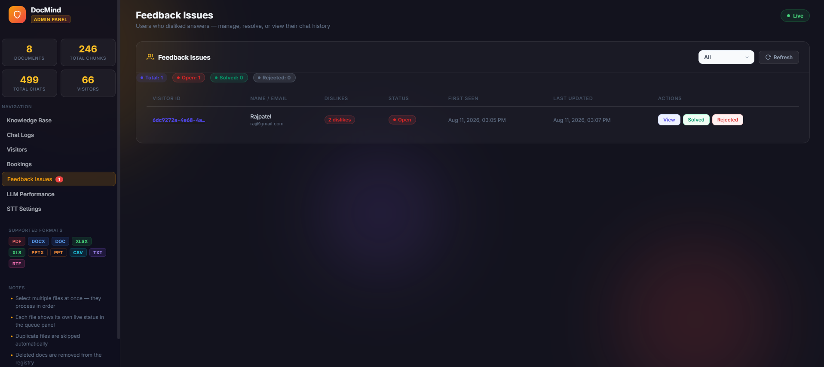
Description: Negative feedback queue allowing admins to track disliked answers, inspect context, and manage resolution statuses (Open, Solved, Rejected).

Figure 6.14: Disliked Conversation Deep-Dive Modal
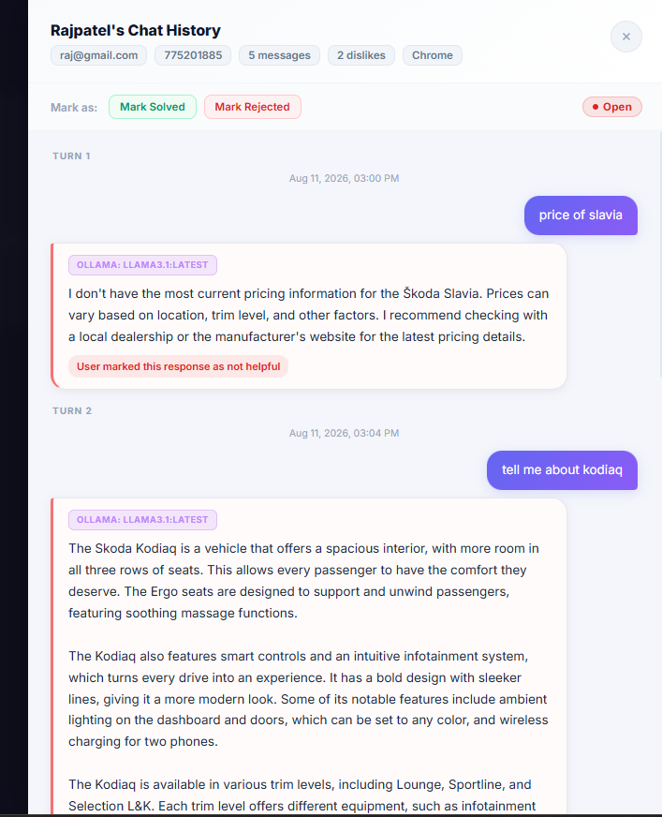
Description: Turn-by-turn conversation viewer showing marked unhelpful answers (e.g., user Raj Patel asking for 'price of slavia') to guide knowledge base updates.

Figure 6.15: LLM Performance & Satisfaction Metrics
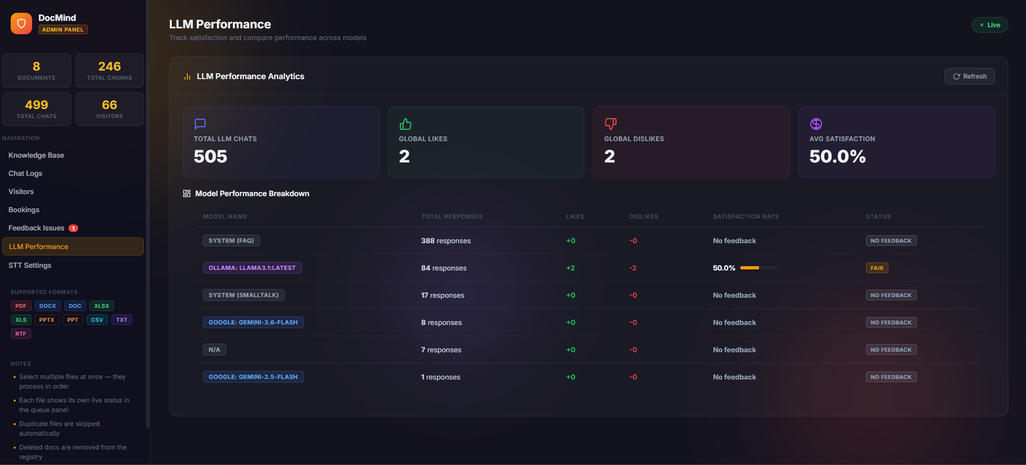
Description: Analytics dashboard displaying global chats (505), positive/negative reactions, satisfaction rates (50.0%), and granular model-by-model performance breakdowns.

Figure 6.16: Multi-Provider Speech-to-Text Switcher
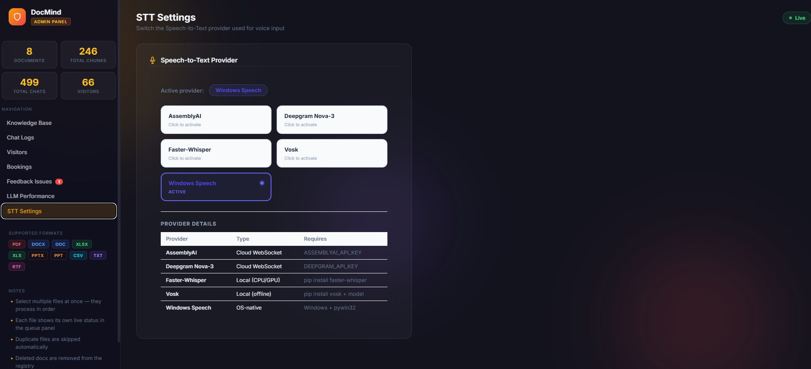
Description: STT settings interface enabling instant hot-swapping between cloud WebSocket providers (AssemblyAI, Deepgram) and local offline engines (Faster-Whisper, Vosk, Windows SAPI).

7. API & Route Reference

7.1 Client Application (app.py — Port 5000)
HTTP Method | Endpoint | Description
GET | / | Serves the main DocMind chat web interface.
POST | /ask | Submits a user query; executes Smalltalk filter or full RAG pipeline.
POST | /api/feedback | Records user rating (+1 like / -1 dislike) on a response.
POST | /api/user-info | Persists lead generation details (Name, Email, Phone) to MongoDB.
GET | /documents | Returns active documents list in JSON format.
POST | /clear-history | Clears conversational context memory for the session.
WS | /socket.io | WebSocket endpoint for real-time 16kHz PCM audio streaming.

8. Installation, Configuration, & Deployment
# 1. Initialize Virtual Environment & Install Dependencies
python -m venv chatbot_test_env
.\chatbot_test_env\Scripts\Activate.ps1
pip install -r requirements.txt
# 2. Pull Required Ollama Models (If running locally)
ollama pull llama3.1
ollama pull bge-m3
# 3. Launch System Services
.\start_servers.bat
# Web Access:
# User Chat UI: http://localhost:5000
# Admin Console: http://localhost:5001/admin/

